HemoSim edit doc - I13
HOW TO USE: edit the wording directly (Track Changes if you like). For layout or a figure (size, position, wrong/missing image) write a short instruction in [brackets] right where it applies. Send it back and I apply the wording to the page and the layout notes to the styling, then regenerate. This is a content+notes doc, so it will not look exactly like the web page.

ISSUES FLAGGED FOR THIS MODULE (5)
These were found while the module was built and are not part of the prose. SOURCE means the defect is in a deck, a Notion page or the source index and has to be fixed there too. DECISION means it needs your call before the page is final. NOTE is for information. Answer them in [brackets] like any other instruction.
[DECISION: The curriculum states two different PPV thresholds. Deck summary slide 203 gives 12.5 percent, ANDROMEDA-SHOCK-2 uses 13 percent. The page publishes the provenance of both rather than picking one. Decide whether the curriculum should state a single number.]
[NOTE: The threshold published is 13 percent from Michard 2000, PMID 10903232. The meta-analysis is Marik 2009, PMID 19602972, 29 studies, 685 patients, PPV AUC 0.94, threshold 12.5 plus or minus 1.6 percent. Messina 2023 is published as counterweight: 59 studies, 2,947 patients, AUC 0.77, threshold 10.8 percent. The grey zone is Cannesson 2011 and Biais 2014.]
[NOTE: No human study of PPV validity in intra-abdominal hypertension exists. Only porcine data is given, Renner and Jacques, and the page states that human thresholds are unestablished.]
[SOURCE: INDEX.md section 4 lists slide177 and slide180 as two figures for this module. They are the same image.]
[NOTE: The deck's slide 183 says "about 12.5 percent variation for both indices". Marik 2009 gives 12.5 percent for PPV, 11.6 for SVV, and no SPV threshold. The page follows the paper.]

Evaluating arterial systolic and pulse pressure variation
Module I12 followed a single positive pressure breath through the circulation and left the arterial trace oscillating. Inspiration reduces the gradient for venous return and raises the load the right ventricle ejects against, so right ventricular output falls. Two to four beats later that deficit arrives at the left ventricle, and the arterial pulse gets smaller. The mechanism is complete. What it does not yet supply is a measurement: a number, a threshold, and an honest account of what the number is entitled to claim.
Module I11 introduced the two indices as instruments among instruments, gave the threshold and listed the preconditions. This module is what that section deferred to. It takes systolic pressure variation apart into the components it was originally defined by, derives pulse pressure variation and says why it displaced the older index, traces the threshold back to the studies that produced it, and then spends its second half on the failure modes.
One claim organises that second half. Every condition that invalidates these measurements does so by breaking one link in a chain running from the ventilator to the arterial trace. Spontaneous effort, a small tidal volume, an arrhythmia, right ventricular failure, an open chest, a tense abdomen, a rapid respiratory rate and a stiff lung are not eight rules to memorise. They are eight places where a single chain fails, and naming the place tells you both the direction of the error and which alternative test escapes it. A clinician who holds only the list cannot judge the patient the list does not cover, and a modern intensive care unit is largely full of those patients.

The chain the measurement depends on
Reading a fluid responsiveness test off an arterial line is an inference with five steps. The ventilator delivers a tidal volume. Some fraction of the resulting airway pressure reaches the pleural space. That pleural pressure change alters the transmural pressure across the great veins and both ventricles, the quantity Module I3 defined and the only one the circulation actually responds to. The change in transmural pressure produces a change in stroke volume, but only in proportion to the slope of the cardiac function relationship at the patient's operating point. Finally, the change in stroke volume appears as a change in arterial pulse pressure.
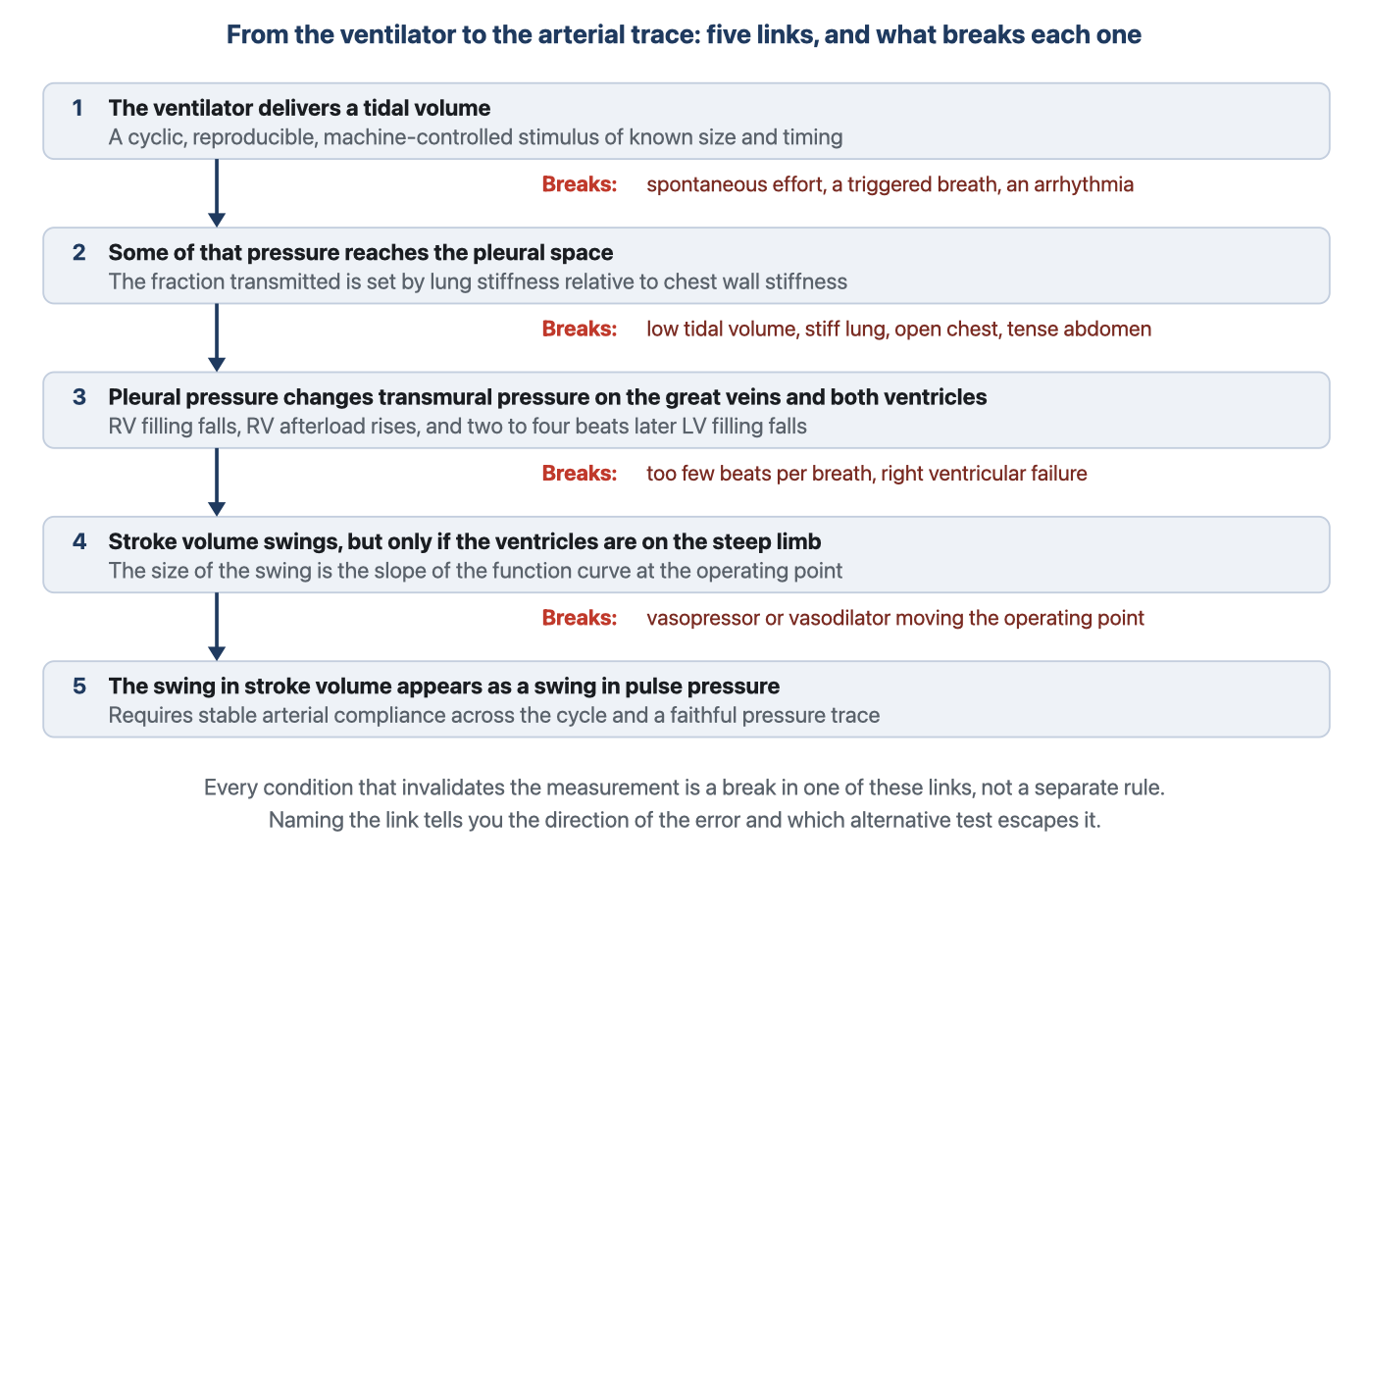
The inference behind the number. The list of conditions that invalidate systolic and pulse pressure variation is not a list at all, it is this chain read backwards.
[Layout note: figure shown small here. On the web it is currently capped at 640px wide. Say if you want it smaller/larger, moved, cropped, or replaced.]
The last step is the one usually taken on trust. The arterial system behaves as a Windkessel, developed in Module I4, and to a good approximation the pulse pressure generated by a single ejection is the volume ejected divided by the compliance of the arterial tree.
PP ≈ SV ÷ CartPP, arterial pulse pressure; SV, left ventricular stroke volume; Cart, total arterial compliance. Across the three to eight beats of one respiratory cycle, arterial compliance and systemic vascular resistance change very little, so a change in pulse pressure over that window is a change in stroke volume scaled by a constant that nobody has to know.
That is the entire licence for reading a flow signal off a pressure trace, and it holds only over a short window. Arterial compliance differs enormously between a twenty-five year old and a calcified eighty year old, which would make an absolute pulse pressure useless across patients. Expressing the swing as a fraction of its own mean cancels the constant. Much of the design of these indices is that same trick, taking a ratio or a difference so an unknown term drops out. Putting the chain together as a proportionality makes the structure visible, and the structure is the point of the module.
PPV ∝ ΔPpl × (dSV ÷ dPTM) ÷ SVmeanΔPpl, the swing in pleural pressure produced by the breath, which is the size of the provocation; dSV ÷ dPTM, the slope of the cardiac function relationship at the patient's operating point, which is preload responsiveness itself; SVmean, mean stroke volume across the cycle. Written as a proportionality to expose the structure, not as a formula to compute with.
[Physiologic Insight box: A single value of pulse pressure variation is one number containing the product of two unknowns. One is the size of the provocation, meaning how far pleural pressure actually moved, which depends on the tidal volume, on the stiffness of the chest wall relative to the lung, on the abdomen and on whether the patient contributed effort of their own. The other is the quantity you are trying to measure, the steepness of the function curve at the operating point. No arithmetic recovers two factors from their product. That is why the index is interpretable only inside a set of conditions that pin the first factor down, and why every manoeuvre that rescues the test holds one factor constant while deliberately varying the other. The tidal volume challenge fixes the patient and changes the provocation. A passive leg raise fixes the provocation and changes the operating point. Read that way the rescues stop being tricks and become the only two moves available.]

Systolic pressure variation, and the reference beat
Perel and colleagues defined systolic pressure variation in 1987 as the difference between the maximum and the minimum systolic pressure following a single positive pressure breath, and they did something in that first experiment that is easy to skate past. They divided the swing into two components measured against the systolic pressure during a five second apnoea, and they fitted the dogs with a continuously inflated vest around the chest in order to hold the ratio of lung to chest wall compliance near the human value of 0.83. The founding study of this whole literature had to engineer the pressure transmission fraction before the model would behave like a person. That fact is a warning about the second link of the chain, delivered thirty-nine years early.
SPV = SBPmax − SBPmin
ΔUp = SBPmax − SBPref
ΔDown = SBPref − SBPminSBPmax and SBPmin, the highest and lowest systolic pressures over one respiratory cycle; SBPref, the reference systolic pressure taken during a short end-expiratory apnoea. SPV is reported in mmHg rather than as a percentage, which matters for comparing one patient with another.
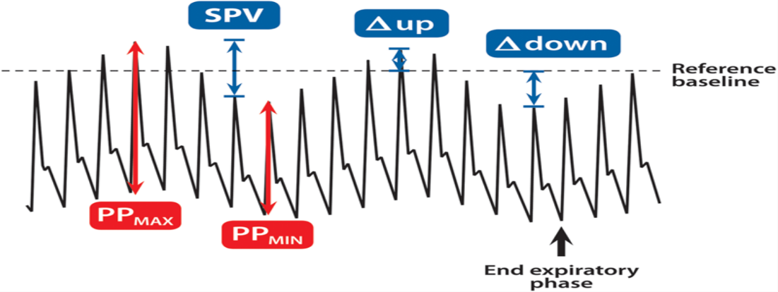
The whole of both indices on one tracing. In blue, systolic pressure variation and its two components, each measured against the systolic pressure of the end-expiratory reference beat. In red, the largest and smallest pulse pressures over the same cycle, which are the two quantities pulse pressure variation is built from.Source: HemoSim hemodynamics module (v2022), slide 177, after Biais M, Ouattara A, Janvier G, Sztark F. Anesthesiology. 2012;116(6):1354-1361.
[Layout note: figure shown small here. On the web it is currently capped at 640px wide. Say if you want it smaller/larger, moved, cropped, or replaced.]
The two components arise from opposite sides of the heart and arrive at different moments, which is why splitting them was worth doing.
ΔDown is the delayed right sided signal. Inspiration reduces venous return and loads the right ventricle, right ventricular output falls, and after transit through the pulmonary circulation that deficit presents itself to the left ventricle as a smaller filling volume. The fall in left ventricular stroke volume therefore appears during expiration, two to four beats after the breath that caused it. Its size is set by how steeply left ventricular output depends on filling, which is preload responsiveness itself, so ΔDown carries the information the test is being used for.
ΔUp is the immediate left sided signal. During inspiration rising pleural pressure squeezes pulmonary venous blood forward into the left atrium and simultaneously reduces left ventricular transmural pressure during ejection, a genuine reduction in afterload. Both raise stroke volume for a beat or two. ΔUp is therefore not a preload signal, and the mechanism says where it should be prominent: in an afterload sensitive, which is to say failing, left ventricle, and where there is a high pulmonary blood volume for the breath to squeeze. Reading a large total systolic pressure variation as evidence of hypovolaemia, without asking which component produced it, is the error the decomposition was invented to prevent.
The animal work behind the components is unusually clean. In ten ventilated dogs bled in steps of five, ten, twenty and thirty percent of estimated blood volume, systolic pressure variation tracked the volume removed with a rank correlation of 0.993 and ΔDown with 0.981, both at least as good as cardiac output and both far better than central venous pressure. A companion experiment tested whether the signal is specific to hypovolaemia rather than to hypotension. Dogs brought to a mean arterial pressure of 50 mmHg by haemorrhage had a systolic pressure variation of 15.7 plus or minus 6.7 mmHg, against 9.1 plus or minus 2.0 mmHg in dogs brought to the same pressure by sodium nitroprusside, while central venous and wedge pressures did not differ between the groups at all.
The human confirmation came from Tavernier and colleagues, in fifteen patients with sepsis-induced hypotension across thirty-five graded volume loading steps. ΔDown discriminated better than left ventricular end-diastolic area on transoesophageal echocardiography and better than the pulmonary artery occlusion pressure, and a ΔDown above 5 mmHg carried a positive predictive value of 95 percent and a negative predictive value of 93 percent. A feature of the arterial trace beat an echocardiographic measurement of the ventricle itself.
Two practical obstacles, and they are why the field moved on. The first is the reference beat: ΔUp and ΔDown are defined against the systolic pressure during a brief apnoea, so obtaining them needs an expiratory hold and a clinician watching the trace during it. Bedside monitors cannot produce that reference, so they report the total swing and nothing else. The second is that systolic pressure variation is expressed in millimetres of mercury rather than as a fraction. Ten millimetres means something quite different at a baseline pulse pressure of 30 than at 70, and no normalisation is built into the definition.
[Offshoot / At-the-Bedside link: Before reading either index, change how the trace is displayed. The default sweep speed is chosen to show the shape of a single beat, which is the wrong setting for a signal whose period is a whole breath. Slow it until two or three respiratory cycles fit across the screen, and expand the pressure scale so the swing occupies a usable fraction of the height. Variation that is invisible at 25 mm per second on a 0 to 200 mmHg scale is obvious once both are adjusted, and a displayed number should always be checked against a trace you have looked at yourself.]
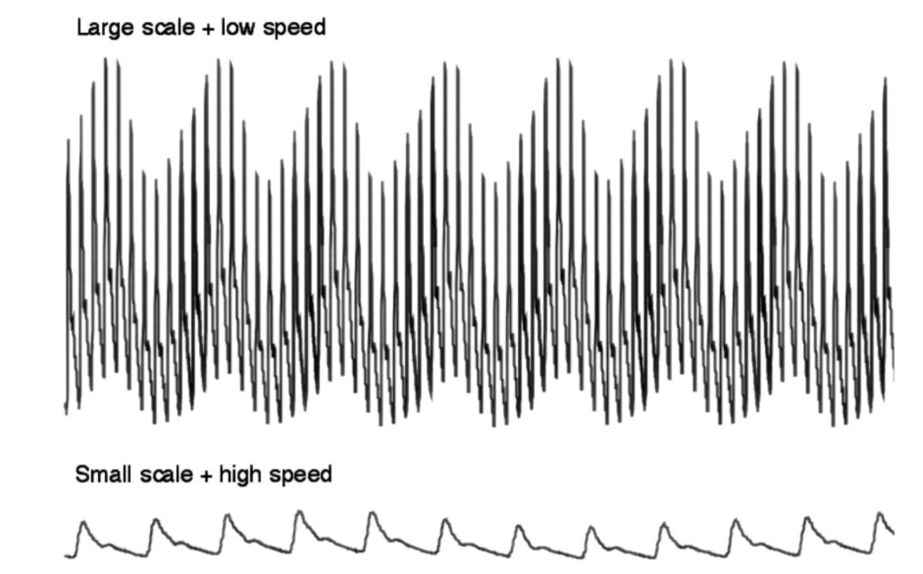
The same arterial signal, displayed two ways. The respiratory swing is a property of the recording that is either visible or not depending entirely on the sweep speed and the scale.Source: HemoSim hemodynamics module (v2022), slide 152.
[Layout note: figure shown small here. On the web it is currently capped at 640px wide. Say if you want it smaller/larger, moved, cropped, or replaced.]

Pulse pressure variation, and why it displaced the older index
Systolic pressure variation has a defect that is structural rather than practical. The thoracic aorta sits inside the chest, so a rise in pleural pressure raises the pressure inside it whether or not the ventricle ejected anything different. Part of the systolic swing is therefore direct transmission of pleural pressure into the vessel rather than a change in stroke volume, and the two are superimposed with no way to tell them apart. Diastolic pressure moves for the same reason, which is what makes the fix available.
Pulse pressure is systolic minus the immediately preceding diastolic pressure, both measured within the same beat and therefore at essentially the same pleural pressure. Subtracting them cancels whatever pleural pressure was doing to both and leaves the part that came from the ejection. This is the manoeuvre the Wheatstone bridge performs in the transducer described in Module I3: take a difference across two arms and any influence acting equally on both disappears from the output. Here the common influence is the pressure surrounding the aorta, and that it cancels is the whole argument for preferring pulse pressure.
PPV = 100 × (PPmax − PPmin) ÷ [(PPmax + PPmin) ÷ 2]PP, arterial pulse pressure, systolic minus the preceding diastolic pressure; PPmax and PPmin, the largest and smallest values over a single respiratory cycle. Dividing by the mean of the two makes the index a percentage, so it is comparable between patients with very different arterial compliance.
Michard and colleagues put the two indices head to head in 2000, in forty mechanically ventilated patients with acute circulatory failure related to sepsis. Before fluid, the respiratory change in pulse pressure was 24 plus or minus 9 percent in the sixteen responders against 7 plus or minus 3 percent in the twenty-four non-responders, while the change in systolic pressure was 15 plus or minus 5 against 6 plus or minus 3 percent. Both separated the groups and the pulse pressure version was the more accurate. A threshold of 13 percent gave a sensitivity of 94 percent and a specificity of 96 percent, and the baseline value predicted the size of the rise in cardiac index with an r2 of 0.85. Volume expansion then halved the variation, from 14 plus or minus 10 to 7 plus or minus 5 percent, and the fall correlated with the rise in cardiac index. That last observation is the seed of an idea developed at the end of this module, that the index is more useful watched over time than read once.
The pooled comparison came from a systematic review of twenty-nine studies enrolling 685 patients, of whom 56 percent responded to a fluid challenge. The areas under the curve were 0.94 for pulse pressure variation, 0.86 for systolic pressure variation and 0.84 for stroke volume variation, against 0.55 for central venous pressure and 0.64 for left ventricular end-diastolic area index. The mean threshold was 12.5 plus or minus 1.6 percent for pulse pressure variation and 11.6 plus or minus 1.9 percent for stroke volume variation. One caution: stroke volume variation reported by a pulse contour monitor is computed from the same arterial waveform by an algorithm, so it is not an independent second opinion. It is the same measurement passed through a model of the arterial tree.

Where twelve or thirteen percent comes from
A threshold is not a physiological constant. It is the cut point that best separated two groups in a particular population, under a particular definition of a response, using a particular method to measure flow. Change any of the three and the cut point moves. Since the number will be quoted at you as though it were a property of nature, the provenance is worth having.
Source | Population | Size | Area under the curve | Threshold
Michard 2000 | Septic shock, passively ventilated, single centre | 40 | Not stated | 13 %
Marik 2009, pooled review | Mixed, 29 studies of ventilated patients | 685 | 0.94 | 12.5 ± 1.6 %
Yang 2014, meta-analysis | Intensive care, restricted to tidal volume above 8 mL/kg, no spontaneous effort, no arrhythmia | 807 | 0.94 | Threshold effect present
Messina 2023, pooled review | Surgical patients in the operating room, 59 studies, unrestricted | 2947 | 0.77 | 10.8 %
The best performances come from the most tightly selected populations. The meta-analysis restricted to patients ventilated above 8 mL/kg with a regular rhythm and no spontaneous effort found a pooled sensitivity of 0.88 and specificity of 0.89, which is an excellent test. The pooled analysis of fifty-nine operating room studies, with no such restriction, found an area under the curve of 0.77, which is a mediocre one. These are the same finding stated twice: the index performs as advertised in patients who satisfy its assumptions, and the published accuracy is a statement about the selection as much as about the index.
Two further choices, buried in the methods sections, move the threshold. The first is the definition of a responder, almost always a rise in cardiac index or stroke volume of 15 percent, a convention that sits uncomfortably close to the reproducibility of some of the methods used to measure it. The second is which flow measurement defines the truth: a meta-regression of thirty-three studies in patients ventilated at or below 8 mL/kg found that the method used to measure cardiac output, and therefore to classify responders, significantly influenced the apparent performance of both indices.

The grey zone
A single cutoff forces every patient into one of two categories, which misrepresents what a test does when its two distributions overlap. The grey zone approach reports instead the range of values within which the test does not classify reliably, together with the proportion of patients who land there. Applied to pulse pressure variation it produces the most useful single result in this literature.
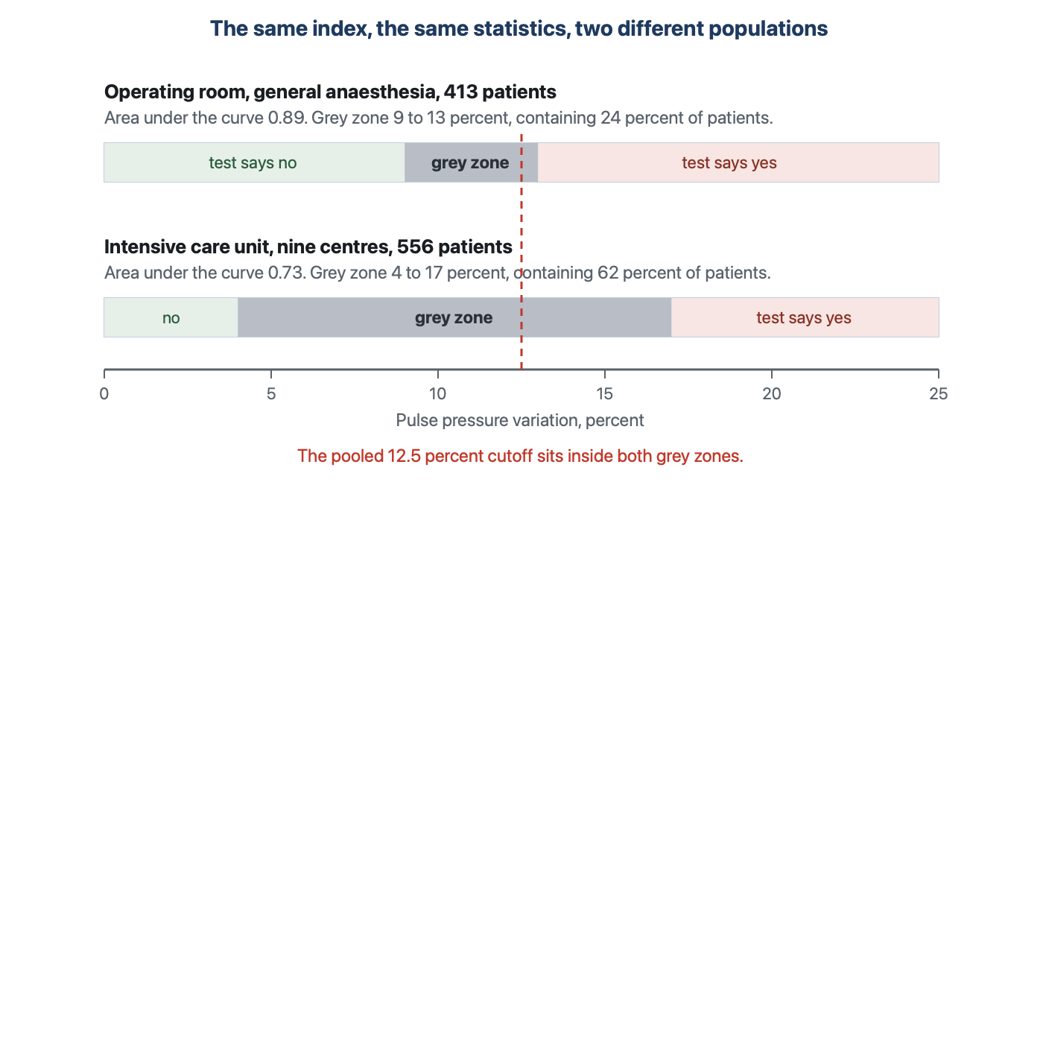
The grey zone in two settings. The same index, analysed by the same method, is inconclusive in a quarter of anaesthetised surgical patients and in nearly two thirds of intensive care patients who already satisfy the validity criteria.
[Layout note: figure shown small here. On the web it is currently capped at 640px wide. Say if you want it smaller/larger, moved, cropped, or replaced.]
In 413 patients under general anaesthesia across four centres, pulse pressure variation had an area under the curve of 0.89 against 0.57 for central venous pressure, and the grey zone ran from 9 to 13 percent, containing 98 patients or 24 percent of the cohort. In 556 patients pooled from nine French intensive care units the area under the curve was 0.73 and the grey zone ran from 4 to 17 percent, containing 62 percent. Those patients had already been selected for satisfying the validity prerequisites, and in them values across that whole range did not predict fluid responsiveness.
The practical reading of a grey zone value is not a small correction to the usual one. A pulse pressure variation of 11 percent in an intensive care patient is not a negative test, and it is not a weakly positive one either. It is a non-answer, and the response is to reach for a provocation whose assumptions the patient does satisfy, which is what the selection table in Module I11 is for. The commonest error is to treat a grey zone value as confirmation of whatever you were already inclined to do.
The same analysis shows what the cutoff ought to depend on. When the intensive care data were reanalysed weighting for the harm of giving fluid to a hypoxaemic patient who would not benefit, the grey zone shifted down to 2 to 13 percent, because the cost of a false positive had risen. A threshold is a decision, not a fact, and it should move with the consequences of being wrong in each direction.

The chain, link by link
What follows is the substance of the module. Each subsection takes one link of the chain, says what breaks it, predicts the direction of the resulting error from the mechanism, and gives the evidence where evidence exists.
The measurement treats the breath as a standardised provocation of known size, repeated identically. Spontaneous effort destroys that in two ways at once. It changes the sign, since a spontaneous breath lowers pleural pressure where a mechanical one raises it, so the phase inverts and a monitor algorithm keyed to the mechanical pattern is reading the wrong beats. And it changes the amplitude unpredictably, because tidal volume during spontaneous or supported breathing is neither set nor easily measured. The first factor in the proportionality becomes an unknown that changes every few seconds.
The empirical result is worse than a loss of accuracy. In twenty-one critically ill patients with spontaneous respiratory movements, nine on pressure support and twelve breathing through a face mask, the respiratory change in pulse pressure varied between 0 and 49 percent at baseline and did not differ at all between responders and non-responders. Its area under the curve was 0.40, which is worse than a coin toss, while the pulmonary artery occlusion pressure managed 0.73 in the same patients. A test that inverts is more dangerous than one that is silent.
A second failure is specific to spontaneous breathing. A large inspiratory effort lowers right atrial pressure, which increases venous return only until the great veins reach flow limitation, the ceiling Module I8 establishes. A patient already at or near maximum venous return can make a very large effort and recruit almost no additional flow, so the arterial swing is small. That patient looks unresponsive on the trace and will nonetheless raise cardiac output when the reservoir is filled, because filling shifts the venous return relationship rightward and lifts the ceiling itself. The mechanism of that false negative sits entirely on the venous side.
The bedside criterion is narrower than it sounds. A patient who triggers the ventilator, even intermittently and even in a mode that looks controlled on the screen, has contributed effort of unknown size. What matters is not the ventilator mode but whether the patient is passive during the beats being measured.
This is the link where the transmural argument does the most work, and where the conventional teaching is subtly wrong in a way that matters.
The familiar rule is that tidal volume must be at least 8 mL/kg of predicted body weight, and the evidence for it is direct. In sixty ventilated patients requiring a fluid challenge, a 12 percent pulse pressure variation classified patients correctly 88 percent of the time when tidal volume exceeded 8 mL/kg and 51 percent of the time when it was below, and 8 mL/kg was the value that best separated the two behaviours. Fifty-one percent is chance. Mechanically the reason is simple: a smaller breath produces a smaller pleural pressure swing, the first factor in the proportionality shrinks, and the product shrinks with it whatever the patient's preload responsiveness. The error is directional, so a small variation at 6 mL/kg does not license the conclusion that a patient is volume replete.
The subtler and more useful result is that tidal volume is a proxy for the quantity that matters, and not a reliable one. In fifty-four patients with circulatory shock, twenty-seven of them with acute respiratory distress syndrome, pulse pressure variation correlated with respiratory system compliance at r of 0.58 and did not correlate with tidal volume at all. Above a compliance of 30 mL/cmH2O the index performed superbly, with an area under the curve of 0.98 against 0.91 for a passive leg raise and 0.97 for an end-expiratory occlusion. At or below 30 mL/cmH2O it fell to 0.69 while the leg raise held at 0.94 and the occlusion test at 0.93. The two provocations that do not depend on transmission through the chest were untouched by the thing that destroyed the one that does.
That is exactly what the transmural chain predicts. The circulation responds to the change in pleural pressure. The pleural pressure change produced by a given tidal volume is set by the chest wall, while the airway pressure needed to deliver that volume is set by the lung. A stiff lung inside a normal chest wall needs a high airway pressure to move a small volume, and very little of that pressure reaches the pleural space, which is the transmission-fraction argument Module I3 makes about correcting a filling pressure for positive end-expiratory pressure. The paired prediction is the one clinicians less often make: a stiff chest wall transmits more, not less, so in obesity, intra-abdominal hypertension and chest wall oedema a modest tidal volume can generate a large arterial swing at any given degree of preload responsiveness.
The rule to carry is therefore not "tidal volume above 8 mL/kg". It is that the provocation must be large enough at the pleural space, that tidal volume, chest wall compliance and lung compliance jointly determine whether it is, and that respiratory system compliance is the better single indicator of the three.
Two conditions break the third link, and although they look unrelated they fail for the same reason: the index is a comparison between beats, and it assumes the only systematic difference between them is where they sit in the respiratory cycle.
Arrhythmia. In atrial fibrillation the filling time varies from beat to beat by more than the respiratory cycle varies it, so stroke volume varies for a reason that has nothing to do with the ventilator. The largest and smallest pulse pressures in a window are then selected by the rhythm rather than by the breath, and no algorithm can separate the two sources because both appear as beat-to-beat variability in the same signal. The error has no reliable direction, which is worse than a directional one. It cannot be corrected for, only avoided.
Too few beats per breath. This one is quantified precisely. In seventeen hypovolaemic patients the respiratory rate was raised from 14 to 16 breaths per minute up to 30 or 40 while holding tidal volume and the inspiratory to expiratory ratio constant. Pulse pressure variation fell from 21 percent, with an interquartile range of 18 to 31, to 4 percent, with a range of 0 to 6. Respiratory variation in aortic flow fell from 23 to 6 percent. Cardiac index did not change, and neither did the patients. Variation became negligible once the ratio of heart rate to respiratory rate fell below 3.6.
The reason is more useful than the number. The reduction in left ventricular stroke volume is the delayed consequence of a reduction in right ventricular output, arriving two to four beats later, which is the phase delay Module I12 develops. With only three or four beats in a respiratory cycle, the trough produced by one breath arrives at the same time as the peak produced by the next and the two partially cancel before either is fully expressed. The stimulus is unchanged, the responsiveness is unchanged, and the readout collapses because the circulation is being asked to complete a two to four beat process inside a three beat window.
The same experiment confirms that this is a transmission phenomenon and not a loss of provocation. While pulse pressure variation collapsed from 21 to 4 percent, the respiratory variation in superior vena caval diameter was essentially unchanged, 38 percent falling to 32. The right sided signal, generated and read immediately, survived. The left sided signal, which has to travel through the pulmonary circulation and arrive several beats later, did not. Right and left indices of preload variation dissociate, and knowing which side of the circulation an index reads tells you which conditions will destroy it.
The index is positive when the whole cardiopulmonary unit sits on the steep part of its function relationship. It is also positive whenever anything else makes right ventricular output fall during inspiration, and the arterial trace cannot tell the two apart. That is the mechanism of the false positive, and right ventricular failure is where it is common.
Inspiration loads the right ventricle in two ways that Module I9 develops. Lung inflation compresses alveolar vessels and raises pulmonary vascular resistance, and the transmural pressure the right ventricle must generate rises with alveolar pressure. A right ventricle with reserve absorbs this. One already near the limit of what it can eject against cannot, so its output falls with each breath for afterload reasons alone, at any filling volume. The monitor reports a large variation and the patient is not fluid responsive at all. Filling that patient dilates the right ventricle further, worsens the septal shift and can reduce cardiac output.
Mahjoub and colleagues quantified this in thirty-five ventilated patients selected for having a pulse pressure variation above 12 percent. Twelve, 34 percent, did not respond to 500 mL of colloid. Before the fluid, the peak systolic velocity of tricuspid annular motion on tissue Doppler was 0.13 plus or minus 0.04 m/s in the non-responders against 0.20 plus or minus 0.05 in the responders, and a cutoff of 0.15 m/s separated them with a sensitivity of 91 percent and a specificity of 83 percent, area under the curve 0.87. One in three positive tests was a false positive attributable to the right ventricle, and a single echocardiographic measurement identified them. That is why tricuspid annular peak systolic velocity appears among the validity criteria cited in Module I11, and it is the criterion clinicians most often omit.
Both are transmission problems, but they fail in opposite directions and deserve separating.
An open chest abolishes the provocation. With the pleural space open to the room there is no pleural pressure to speak of, the applied airway pressure inflates the lung without compressing anything around the heart, and transmural pressures on the great veins and the ventricles barely move. In twenty-two patients undergoing coronary artery bypass grafting, given defined volume loads of 10 mL/kg intraoperatively with the chest open and again within an hour of arrival in the intensive care unit with it closed, every preload index failed with the chest open, static and dynamic alike. In the same patients with the chest closed, pulse pressure variation had an area under the curve of 0.884 and stroke volume variation 0.911. The variable that changed was not the patient and not the ventilator. It was whether there was a pleural space.
A tense abdomen amplifies the provocation. Raised intra-abdominal pressure elevates the diaphragm, stiffens the chest wall and raises baseline pleural pressure, so a given tidal volume produces a larger swing. The chain therefore predicts not that the test breaks but that its threshold rises, because more of any observed variation is coming from the transmission term. Two animal studies bear that out and no adequate human study exists. In fourteen pigs a pulse pressure variation of 11.5 percent or more predicted a fluid response before the abdomen was pressurised, and once intra-abdominal pressure was raised to 25 mmHg the discriminating threshold rose to 20.5 percent, while stroke volume variation lost its discrimination altogether. In nine pigs banded to 30 mmHg and then bled, the arterial indices still separated responders from non-responders with areas under the curve between 0.86 and 0.93, but the discriminating value for pulse pressure variation was 41 percent.
Those are pigs, at pressures towards the severe end of what is seen clinically, and human thresholds are not established. What transfers is the direction and the reason. In a patient with a tense abdomen, a pulse pressure variation of 14 percent is not evidence of preload responsiveness at the conventional cutoff, and the honest move is a test that does not depend on the transmission fraction.
The last link is the easiest to check. Everything above assumes the trace on the screen is the pressure in the artery, and Module I3 shows that in roughly a third of patients in one large series it is not. An underdamped or resonant system overshoots systolic and undershoots diastolic, widening every pulse pressure on the trace, and since it does so by an amount that depends on the steepness of each upstroke it does not widen them equally. An overdamped system narrows them and blunts the swing. Either can manufacture or abolish a clinically important variation with nothing happening to the patient. Do the fast flush test before believing a number derived from the waveform, and remember that the site matters too, since pulse pressure is amplified distally and a radial trace is not an aortic trace, a point Module I4 takes up.

Reading change instead of level
Several of these links can be worked around, and every workaround uses the same idea. Instead of reading the level of the index, which contains the unknown transmission term, deliberately change one factor in the proportionality and read how the index responds. The patient becomes their own control and the unknown cancels.
The tidal volume challenge changes the provocation and holds the patient fixed. In a patient ventilated at 6 mL/kg where the index is uninterpretable, tidal volume is raised to 8 mL/kg for one minute, the absolute change is recorded, and the setting is returned. In thirty measurements across twenty patients with acute circulatory failure, a rise in pulse pressure variation of 3.5 percent identified responders with an area under the curve of 0.99, and a rise in stroke volume variation of 2.5 percent gave 0.97. In the same patients at the same moment, both indices, the central venous pressure and the end-expiratory occlusion test measured at 6 mL/kg predicted nothing at all. The interpretation follows from the proportionality: raising the tidal volume raises the first factor by a known proportion, so the resulting change reports the second, the slope of the function curve.
A passive leg raise read on the arterial line changes the operating point and holds the provocation fixed. In a preload responsive patient the leg raise moves the operating point towards the flatter part of the curve, where the same respiratory stimulus produces a smaller swing, so the index should fall and by how much reports responsiveness. In thirty patients without spontaneous breathing or arrhythmia, ventilated at 6 mL/kg, the change in pulse pressure variation during a leg raise detected preload responsiveness with an area under the curve of 0.98, expressed either as an absolute or a relative change. That converts the leg raise, whose usual limitation is needing a real-time flow monitor, into a test doable with an arterial line alone, and it is why the protocol used in the ANDROMEDA-SHOCK 2 trial lists a leg raise read as a fall in pulse pressure variation of 2 percent absolute or 20 percent relative.
Reading the trend is the least formal and the most often available. Michard's original study found that volume expansion halved the variation and that the fall correlated with the rise in cardiac index. A variation that falls as fluid is given, ventilator settings unchanged, reports that the operating point has moved along the curve. One that does not fall despite an adequate challenge reports that it has not. Neither reading needs the absolute value to be interpretable against a threshold, which is why the kinetics survive conditions the level does not.
Two things have no workaround. An arrhythmia defeats the tidal volume challenge as thoroughly as it defeats the static index, because the quantity read is still a beat-to-beat comparison. And an open chest defeats every ventilator-based manoeuvre, because there is no provocation to modulate. In both cases the answer is a test that does not use the ventilator at all, set out in Module I11.
The level also moves with drugs, in a direction easy to misread as progress. In six dogs bled 35 mL/kg, pulse pressure variation rose from 12 to 28 percent and systolic pressure variation from 12.5 to 21 mmHg, while right atrial and pulmonary artery occlusion pressures did not move at all. Norepinephrine then raised cardiac output and significantly reduced both dynamic indices without restoring any of the lost blood volume. The mechanism is the one Module I8 develops, recruitment of unstressed into stressed volume, which slides the patient along the same function curve towards its flatter part. A variation that falls while the vasopressor dose is being escalated has not shown that the patient has been filled, and vasodilators do the reverse.

Putting a number in front of a patient
The table below summarises what has been derived rather than substituting for it. Its value is in the middle columns: knowing the direction of the error lets you act on a number you cannot fully trust, and knowing the broken link lets you choose a replacement test rather than guess at one.
Condition | Link broken | Direction of the error | What to do instead
Spontaneous effort or a triggered breath | The provocation is neither standardised nor of known sign | Unpredictable, and the index inverts. Area under the curve 0.40 | Passive leg raise read as a change in flow, or a fluid challenge
Tidal volume below about 8 mL/kg | The pleural pressure swing is too small | False negative | Tidal volume challenge, or occlusion tests, or a leg raise
Respiratory system compliance at or below 30 mL/cmH2O | Airway pressure is not transmitted to the pleural space | False negative. Area under the curve falls to 0.69 | Leg raise or end-expiratory occlusion, both unaffected
Arrhythmia | Beats are not comparable to one another | Uninterpretable in either direction | Occlusion tests, or a leg raise read across several beats
Heart rate to respiratory rate ratio below 3.6 | The delayed left sided signal cannot complete inside one cycle | False negative | Lower the respiratory rate if permissible, or use a caval or occlusion measure
Right ventricular failure | Output falls with the breath for afterload reasons | False positive, in about a third of positive tests | Measure tricuspid annular systolic velocity, then test with a leg raise
Open chest or open pericardium | There is no pleural pressure to transmit | False negative, and every ventilator-based test fails | Fluid challenge conducted as a formal test
Raised intra-abdominal pressure | Transmission is amplified, not lost | False positive at the usual threshold | Leg raise or occlusion test, since the threshold in humans is unknown
Underdamped or overdamped arterial line | The trace is not the pressure in the artery | Inflated by resonance, abolished by overdamping | Fast flush test and fix the fluid path before reading anything
[Offshoot / At-the-Bedside link: , in order. Look at the ventilator before the monitor: mode, set and delivered tidal volume, respiratory rate, plateau pressure and total positive end-expiratory pressure, and whether any breaths are being triggered. Compute respiratory system compliance and the heart rate to respiratory rate ratio, because both take seconds and both determine whether the number means anything. Look at the rhythm strip. Flush the arterial line and watch the square wave. Only then look at the trace, slowed and expanded, and confirm that what the monitor calls variation is a swing repeating once per breath rather than once every few beats. If the conditions hold and the value is clearly outside the grey zone, you have an answer. If a condition fails, name the link it broke and pick the replacement test from the last column, rather than discounting the number by an unspecified amount.]

What the measurement is actually good for
This literature has moved through three phases and the third is worth adopting. It began as an alternative to filling pressures, and by that comparison it wins overwhelmingly, with an area under the curve near 0.94 against 0.55 for central venous pressure in the same pooled analysis. It then became a threshold, quoted as 12 or 13 percent and applied to whoever had an arterial line, which is the phase that produced the point-prevalence finding that almost nobody in an intensive care unit satisfies its conditions. It is now best understood as a signal whose level is interpretable only inside narrow circumstances and whose change under a deliberate perturbation is interpretable much more widely.
Underneath all three phases sits the transmural argument, which is the part of this module still true after the thresholds have been revised again. The circulation responds to the pressure across the wall of a vessel or chamber, never to the pressure the monitor displays. Every condition catalogued above is a statement about the pressure outside the heart: whether the ventilator or the patient sets it, how much of it reaches the pleural space through the lung, how much the chest wall and abdomen add, and whether it moves the right ventricle for preload reasons or for afterload reasons. Hold that and you can reason about a case that appears on no list, which was the point of teaching it as a mechanism rather than as a rule.
Both indices in this module are read off the arterial side of the circulation. The venous side carries its own respiratory signal and its own reading convention, and Module I14 takes up the right atrial waveform, where the same end-expiratory reference established in Module I3 is what makes one patient's a wave comparable to another's. Module I15 then applies the same discipline to the wedge, where the chain of assumptions is longer still and the transmission of airway pressure decides whether the number is a left atrial pressure or an echo of the ventilator. The full integration, across the chest wall and through the pulmonary circulation, with the disease scenarios that make heart-lung interaction pathological rather than merely measurable, belongs to the Expert pathway.

References
To DROP a reference, strike it. To ADD one, write [add: author, year, journal, roughly what it is] rather than typing the citation out. Do not correct the text of an entry here: every author list, volume, issue, page range, year and DOI is fetched from PubMed when the page is rebuilt, so an edit made here is discarded and a typo made here is caught. This list is what the page currently carries.
1. Perel A, Pizov R, Cotev S. Systolic blood pressure variation is a sensitive indicator of hypovolemia in ventilated dogs subjected to graded hemorrhage. Anesthesiology. 1987;67(4):498-502. doi:10.1097/00000542-198710000-00009.
2. Pizov R, Ya'ari Y, Perel A. Systolic pressure variation is greater during hemorrhage than during sodium nitroprusside-induced hypotension in ventilated dogs. Anesth Analg. 1988;67(2):170-174. PMID 3341566.
3. Tavernier B, Makhotine O, Lebuffe G, Dupont J, Scherpereel P. Systolic pressure variation as a guide to fluid therapy in patients with sepsis-induced hypotension. Anesthesiology. 1998;89(6):1313-1321. doi:10.1097/00000542-199812000-00007.
4. Michard F, Boussat S, Chemla D, Anguel N, Mercat A, Lecarpentier Y, Richard C, Pinsky MR, Teboul JL. Relation between respiratory changes in arterial pulse pressure and fluid responsiveness in septic patients with acute circulatory failure. Am J Respir Crit Care Med. 2000;162(1):134-138. doi:10.1164/ajrccm.162.1.9903035.
5. Michard F, Teboul JL. Using heart-lung interactions to assess fluid responsiveness during mechanical ventilation. Crit Care. 2000;4(5):282-289. doi:10.1186/cc710. Free full text.
6. Michard F. Changes in arterial pressure during mechanical ventilation. Anesthesiology. 2005;103(2):419-428. doi:10.1097/00000542-200508000-00026.
7. De Backer D, Heenen S, Piagnerelli M, Koch M, Vincent JL. Pulse pressure variations to predict fluid responsiveness: influence of tidal volume. Intensive Care Med. 2005;31(4):517-523. doi:10.1007/s00134-005-2586-4.
8. Nouira S, Elatrous S, Dimassi S, Besbes L, Boukef R, Mohamed B, Abroug F. Effects of norepinephrine on static and dynamic preload indicators in experimental hemorrhagic shock. Crit Care Med. 2005;33(10):2339-2343. doi:10.1097/01.ccm.0000182801.48137.13.
9. Heenen S, De Backer D, Vincent JL. How can the response to volume expansion in patients with spontaneous respiratory movements be predicted? Crit Care. 2006;10(4):R102. doi:10.1186/cc4970. Free full text.
10. de Waal EE, Rex S, Kruitwagen CL, Kalkman CJ, Buhre WF. Dynamic preload indicators fail to predict fluid responsiveness in open-chest conditions. Crit Care Med. 2009;37(2):510-515. doi:10.1097/CCM.0b013e3181958bf7.
11. Renner J, Gruenewald M, Quaden R, Hanss R, Meybohm P, Steinfath M, Scholz J, Bein B. Influence of increased intra-abdominal pressure on fluid responsiveness predicted by pulse pressure variation and stroke volume variation in a porcine model. Crit Care Med. 2009;37(2):650-658. doi:10.1097/CCM.0b013e3181959864.
12. De Backer D, Taccone FS, Holsten R, Ibrahimi F, Vincent JL. Influence of respiratory rate on stroke volume variation in mechanically ventilated patients. Anesthesiology. 2009;110(5):1092-1097. doi:10.1097/ALN.0b013e31819db2a1.
13. Mahjoub Y, Pila C, Friggeri A, Zogheib E, Lobjoie E, Tinturier F, Galy C, Slama M, Dupont H. Assessing fluid responsiveness in critically ill patients: false-positive pulse pressure variation is detected by Doppler echocardiographic evaluation of the right ventricle. Crit Care Med. 2009;37(9):2570-2575. doi:10.1097/CCM.0b013e3181a380a3.
14. Marik PE, Cavallazzi R, Vasu T, Hirani A. Dynamic changes in arterial waveform derived variables and fluid responsiveness in mechanically ventilated patients: a systematic review of the literature. Crit Care Med. 2009;37(9):2642-2647. doi:10.1097/CCM.0b013e3181a590da.
15. Jacques D, Bendjelid K, Duperret S, Colling J, Piriou V, Viale JP. Pulse pressure variation and stroke volume variation during increased intra-abdominal pressure: an experimental study. Crit Care. 2011;15(1):R33. doi:10.1186/cc9980. Free full text.
16. Cannesson M, Le Manach Y, Hofer CK, Goarin JP, Lehot JJ, Vallet B, Tavernier B. Assessing the diagnostic accuracy of pulse pressure variations for the prediction of fluid responsiveness: a "gray zone" approach. Anesthesiology. 2011;115(2):231-241. doi:10.1097/ALN.0b013e318225b80a.
17. Monnet X, Bleibtreu A, Ferré A, Dres M, Gharbi R, Richard C, Teboul JL. Passive leg-raising and end-expiratory occlusion tests perform better than pulse pressure variation in patients with low respiratory system compliance. Crit Care Med. 2012;40(1):152-157. doi:10.1097/CCM.0b013e31822f08d7.
18. Biais M, Ouattara A, Janvier G, Sztark F. Case scenario: respiratory variations in arterial pressure for guiding fluid management in mechanically ventilated patients. Anesthesiology. 2012;116(6):1354-1361. doi:10.1097/ALN.0b013e318256ee28.
19. Mahjoub Y, Lejeune V, Muller L, et al. Evaluation of pulse pressure variation validity criteria in critically ill patients: a prospective observational multicentre point-prevalence study. Br J Anaesth. 2014;112(4):681-685. doi:10.1093/bja/aet442.
20. Biais M, Ehrmann S, Mari A, et al. Clinical relevance of pulse pressure variations for predicting fluid responsiveness in mechanically ventilated intensive care unit patients: the grey zone approach. Crit Care. 2014;18(6):587. doi:10.1186/s13054-014-0587-9. Free full text.
21. Yang X, Du B. Does pulse pressure variation predict fluid responsiveness in critically ill patients? A systematic review and meta-analysis. Crit Care. 2014;18(6):650. doi:10.1186/s13054-014-0650-6. Free full text.
22. Myatra SN, Prabu NR, Divatia JV, Monnet X, Kulkarni AP, Teboul JL. The changes in pulse pressure variation or stroke volume variation after a "tidal volume challenge" reliably predict fluid responsiveness during low tidal volume ventilation. Crit Care Med. 2017;45(3):415-421. doi:10.1097/CCM.0000000000002183.
23. Teboul JL, Monnet X, Chemla D, Michard F. Arterial pulse pressure variation with mechanical ventilation. Am J Respir Crit Care Med. 2019;199(1):22-31. doi:10.1164/rccm.201801-0088CI.
24. Alvarado Sánchez JI, Caicedo Ruiz JD, Diaztagle Fernández JJ, Amaya Zuñiga WF, Ospina-Tascón GA, Cruz Martínez LE. Predictors of fluid responsiveness in critically ill patients mechanically ventilated at low tidal volumes: systematic review and meta-analysis. Ann Intensive Care. 2021;11(1):28. doi:10.1186/s13613-021-00817-5. Free full text.
25. Taccheri T, Gavelli F, Teboul JL, Shi R, Monnet X. Do changes in pulse pressure variation and inferior vena cava distensibility during passive leg raising and tidal volume challenge detect preload responsiveness in case of low tidal volume ventilation? Crit Care. 2021;25(1):110. doi:10.1186/s13054-021-03515-7. Free full text.
26. Messina A, Caporale M, Calabrò L, et al. Reliability of pulse pressure and stroke volume variation in assessing fluid responsiveness in the operating room: a metanalysis and a metaregression. Crit Care. 2023;27(1):431. doi:10.1186/s13054-023-04706-0. Free full text.
27. Jozwiak M, Liu J, Teboul JL. Heart-lungs interactions in mechanically ventilated patients: physiology and clinical implications. Intensive Care Med. 2026;52(3):552-554. doi:10.1007/s00134-026-08327-3.

